**PROJECT REPORT ON EDU CONNECT LEARNING**

**1.INTRODUCTION**

**1.1 OVERVIEW**

My project name is Edu connect learning center, EduConnect Learning Center, an educational institution, uses Zoho Books to manage their donations, track expenses, and handle grant finances. They can generate donor receipts, track expenses related to educational programs, and generate financial reports. Zoho Books helps them maintain financial transparency and accountability.

**1.2 PURPOSE**

EDU Learning Center is an innovative education environment where primary and secondary school students can use robots to enhance their knowledge on various school subjects.

The young attendees, from 8 to 19 years old, discover and experience EDU in an engaging session focusing on STEM, Soft Skills and Industrial Culture, which form a basis for their future growth.

**2.PROBLEM DEFINITION & DESIGN THINKING**

2.1 Empathy Map

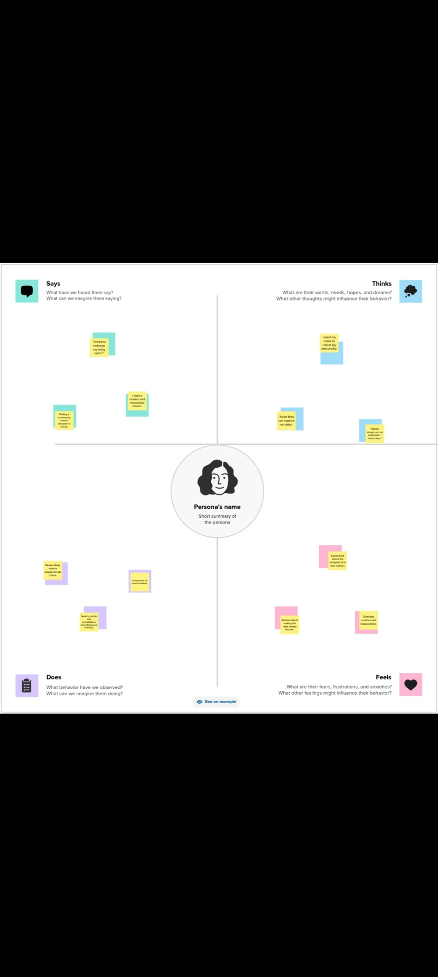

**2.2 Ideation & Brainstroming map**

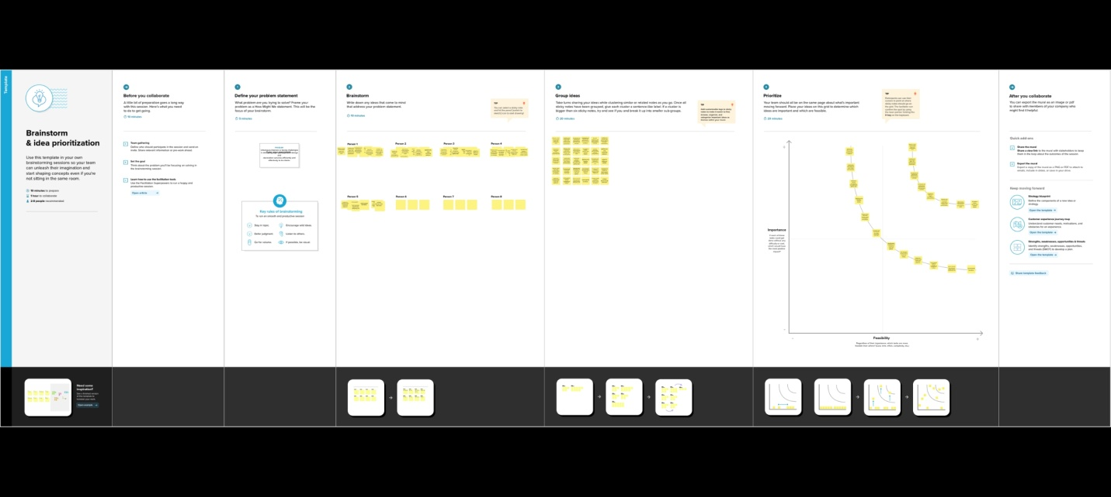

**3.RESULT**

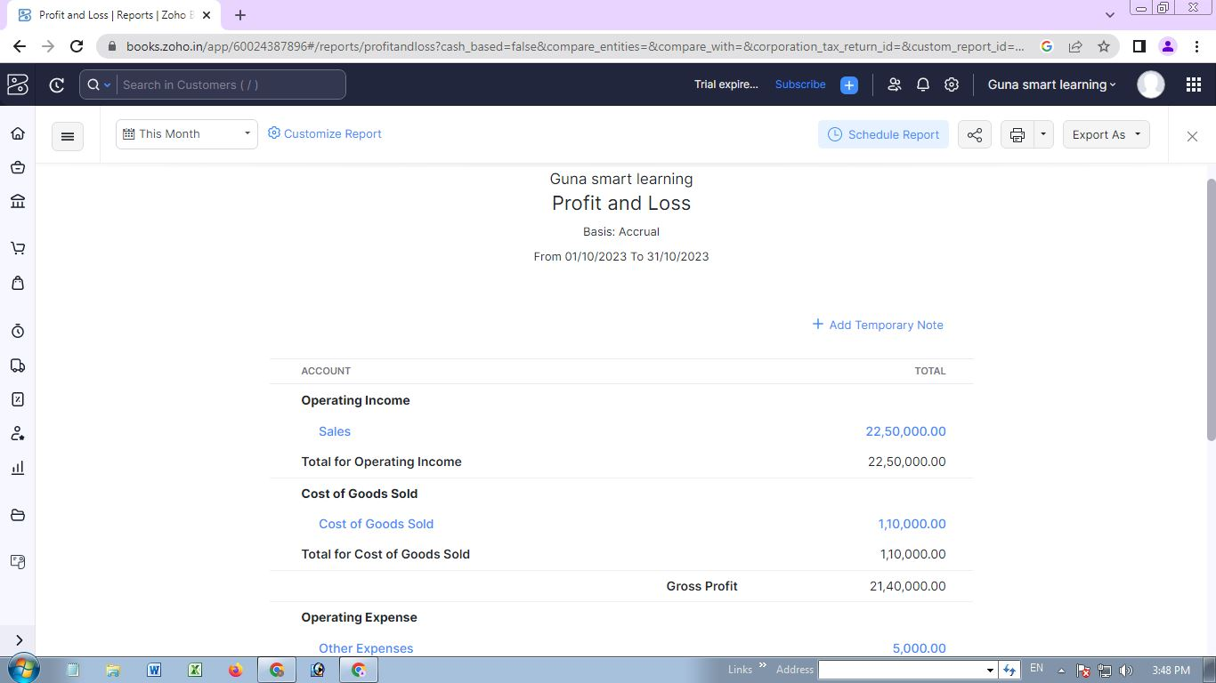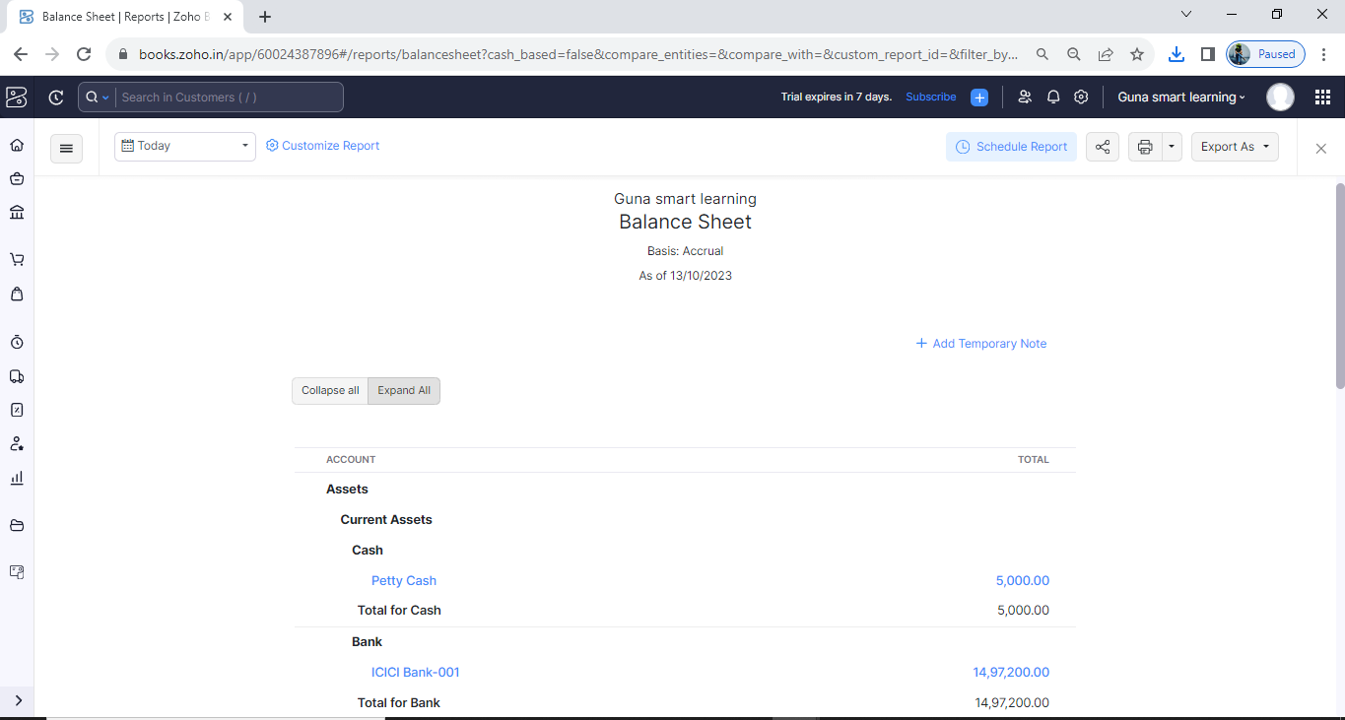

**4. ADVANTAGES & DISADVANTAGES**

**Advantages:**

1. we are able to link the various resources in several varying formats.
2. It is a very efficient way of delivering courses online.
3. Due to its convenience and flexibility, the resources are available from anywhere and at any time.
4. Everyone, who are part time students or are working full time, can take advantage of web-based learning.
5. Web-based learning promotes active and independent learning.
6. As we have access to the net 24x7, we can train yourself anytime and from anywhere also.
7. It is a very convenient and flexible option; above all, we don't have to depend on anyone for anything.
8. Not only can we train ourself on a day to day basis, but also on weekends or whenever we have the free time to.

**Disadvantages:**

1. Most of the online assessments are limited to questions that are only objective in nature.
2. There is also the problem of the extent of security of online learning programs.
3. The authenticity of a particular student's work is also a problem as online just about anyone can do a project rather than the actual student itself.
4. The assessments that are computer marked generally have a tendency of being only knowledge-based and not necessarily practicality-based.

**5. APPLICATIONS**

**GIT HUB AND ZOHO BOOKS** are used to applied the solution.

**6. CONCLUSION**

Edu connect learning center is not just a change of technology. It is part of a redefinition of how we as a species transmit knowledge, skills, and values to younger generations of workers and students. This book makes a few predictions of how edu connect learning center and the functions it serves will continue to develop

**7. FUTURE SCOPE**

The future of edu connect learning center in education is an exciting prospect for educators and learners alike. We can expect to see more interactive learning experiences, more personalized learning, and more options for remote learning in the future.